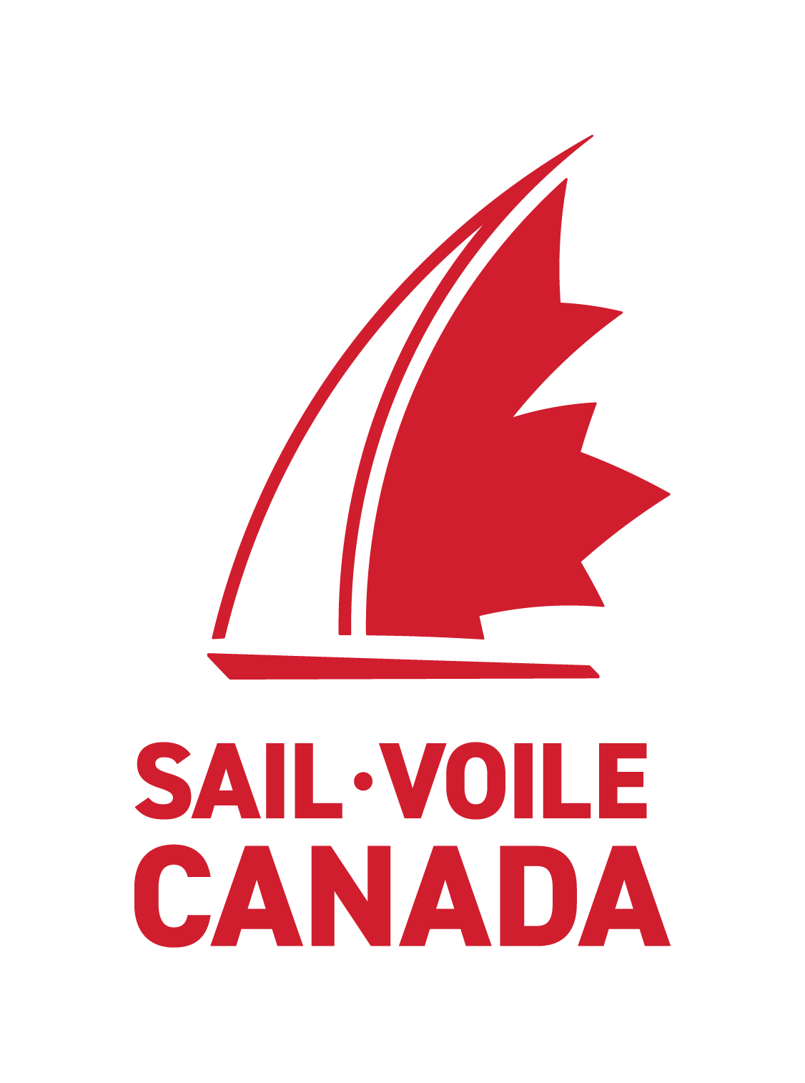
2023 Sail Canada Learning Facilitator Clinic
Candidate Application
Please submit your application along with a Sailing Resume to your Provincial Sailing Association (PSA).
Please contact your PSA for additional application details.
PSA approved applications must be forwarded to Sail Canada for review.
Please review the Sail Canada CANSail Learning Facilitator Eligibility Criteria prior to submitting your application.

Preferred Clinic Location: X Ontario (Buffalo Canoe Club- April 19 - 23, 2023)
(A minimum number of candidates will be required in order for each clinic to run)

Name:
Date of Birth (dd/mm/yy):

Address: City: Province: .

Postal Code:

Telephone (h): E-mail: .

CANSail#: NCCP#:____________

Instructor / Coach Certifications – Please list your Instructor/Coach certifications and details:
Year | Certification | Location of Course (Province) | Learning Facilitator / Instructor Evaluator | Status (Complete / Incomplete)

Previous Teaching Experience – Please list your Instructing / Coaching Experience:
Year | Name & Address of school or club | Level of Sail Canada  Course taught | Name of Director

Why do you want to become a Learning Facilitator?

Previous IDP / CDP Experience (To be completed by re-certifying LFs / IEs only):

Year | Level of Course Taught | Location of course | LF(s)/IE(s) you taught with

Names of references who are knowledgeable of your instructing skills and character may be contacted.

Name | Position or Relationship to Applicant | Phone Number | Email Address

RELEASE

I certify that the information herein is accurate. I understand that by signing and submitting this form I give permission to Sail Canada to contact, in addition to the character references, any of the individuals, schools or clubs named above to verify the information provided. I understand that I am responsible for my behaviour and liable for any damages to the property caused by me.

Signature Date

